JAVA LAB 3 (4)

**Problem:**

Write a JAVA Application that user can draw lines on the **JPanel**.

**Requirement:**

1. You can’t use any static field and method except the main function.
2. You need to provide two “button” for user to choose (just like picture below).
3. “point button” is used to display the coordinate when user clicked.
4. “length button” is used to display the length between two point.
5. The “button” is painted on JPanel , and is activated by mouse event.
6. The size of “button” is **50 * 20px**
7. Stroke width need to be **4.0f**.
8. **Length** must be **round off to the 2nd decimal place**.
9. **Paint on the JPanel directly**, you don’t have to store the brush path.

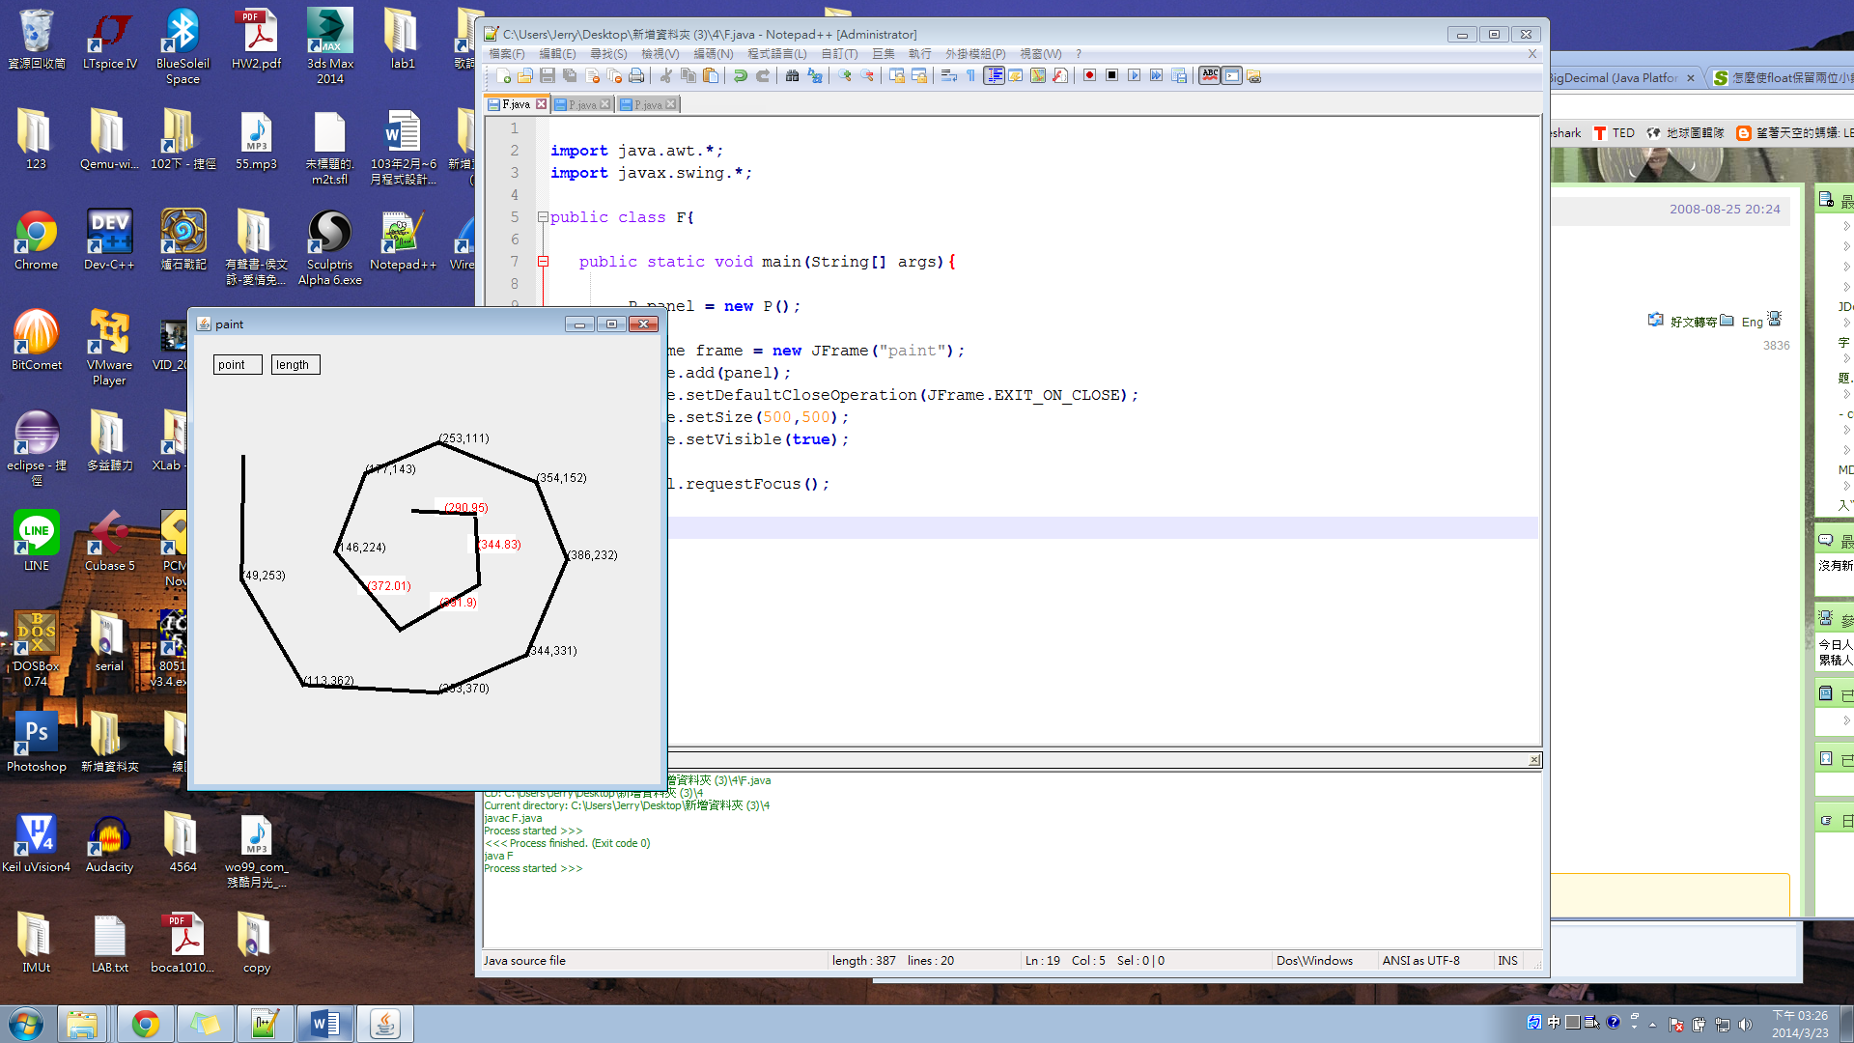

**Class & method:**

Class

import java.awt.*;

import java.awt.event.*;

import javax.swing.*;

import java.util.*;

import java.math.*;

Interface

**MouseListener**

public void mousePressed(MouseEvent event){}

public void mouseReleased(MouseEvent event){}

public void mouseClicked(MouseEvent event){}

public void mouseEntered(MouseEvent event){}

public void mouseExited(MouseEvent event){}

**MouseMotionListener**

public void mouseDragged( MouseEvent event ){}

public void mouseMoved( MouseEvent event ){}

1. addMouseListener()
2. addMouseMotionListener()
3. event.getX()
4. event.getY()
5. Graphics g = getGraphics();
6. Graphics2D g2 = (Graphics2D) g;
7. drawLine(int x1, int y1, int x2, int y2)
8. setStroke(new BasicStroke(lineWidth)); // lineWidth = 4.0f
9. fillRect (int x, int y, int width, int height);
10. setColor(Color color);
11. setVisible();
12. setDefaultCloseOperation(JFrame.EXIT_ON_CLOSE)
13. BigDecimal (自己查)

**Referance:**

1. **Use JAVA Doc**

<http://docs.oracle.com/javase/7/docs/api/overview-summary.html>

1. **getGraphics** VS **paintComponent**

getGraphics method

* Can be null
* Is a "snap shot" of the last paint process
* Anything painted to it will be lost on the next paint cycle

You should avoid using getGraphics and simply use what is past to the paintComponent method.

In theory, there is no difference between them, but if you want what you have painted to survive between repaints, then you should be using paintComponent

[source](http://stackoverflow.com/questions/21129138/difference-between-graphics-object-of-getgraphics-and-paintcomponent)

1. **Graphics** VS **Graphics2D**

[See here](http://docs.oracle.com/javase/7/docs/api/java/awt/Graphics2D.html)